## **EMERGENCY METHODS FOR EARLY DETECTION OF FOREST FIRE**

**RAMAR P**

Department of Electronics

and Communication Engineering,

Sethu Institute of Technology

**VENKATESH R**

Department of Electronics

and Communication Engineering,

Sethu Institute of Technology

**RITHICK SARATHY P**

Department of Electronics

and Communication Engineering,

Sethu Institute of Technology

**SATHYA MOORTHY R C**

Department of Electronics

and Communication Engineering,

Sethu Institute of Technology

.

ABSTRACT

Fire detection at an early stage is important for the safety of the people. Lack of information due to manual detection is the main cause of failure of fire detection. Fire can be detected by using smoke at an early stage as it is the fire indicator. Generally automatic forest fire detection using image processing techniques represents one of the significant aspects of forest fire avoidance earlier. Detection using image and video is effective than using sensors. In image processing the inputs for the fire detection may be an image or a video but the input as a video is quite complex process but provides good result. The techniques such as Wavelet decomposition, spatial and temporal analysis, Gaussian Mixture Model, Multi-Feature fusion detect fire in an accurate manner.

1. **INTRODUCTION**

Wildfires are a significant hazard to ecological systems around the world and pose a serious threat to human safety. People visually look for signs of fire or smoke appearance to detect fire in older days. To detect fire at early stage we use smoke which is the good indicator of fire which is visible before flames. Characteristics of smoke need to be considered such as transparency, its response to environmental condition, its shape. In open environment smoke detection pose a serious challenge in such areas sensors may be used but this has limitations such as time and wide area coverage. To overcome this video fire detection systems are used.

Different image processing techniques can be used to detect fire and smoke. In image processing image or video is taken as input and the output may either an image or parameters or characteristics of an image. Various tasks like analysis classification, extracting the features, recognizing different patterns can be performed using image processing. The features and textures of smoke can extract using various image processing techniques. By using these techniques the dangerous situations caused due to fire can be avoided and safety of the people can be preserved.

1. **LITERATURE SURVEY**

Surapong Surit, Watchara Chatwiriya [8] proposed a method to detect fire by smoke detection in video. This approach is based on digital image processing approach with static and dynamic characteristic analysis. The proposed method is composed of following steps, the first is to detect the area of change in the current input frame in comparison with the background image, the second step is to locate regions of interest (ROIs) by connected component algorithm, the area of ROI is calculated by convex hull algorithm and segments the area of change from image, the third step is to calculate static and dynamic characteristics, using this result we decide whether the object detected is the smoke or not. The result shows that this method accurately detects fire smoke.

1. Piccinini, S. Calderara, and R. Cucchiara [2] proposed a method based on the wavelet model and a color model of the smoke. The proposed method exploits two features: the variation of energy in wavelet model and a color model of the smoke. Smoke is detected based on the decrease of energy ratio in wavelet domain between background and current. The deviation of the current pixel color is measured by the color model. Bayesian classifier is used to combine these two features to detect smoke.

R.Gonzalez proposed a method to detect fire based on Wavelet Transform. Stationary Wavelet Transform is used to detect Region of Interest. This method involves three steps preprocessing, SWT, histogram analysis. In preprocessing unwanted distortions are removed and image is resized and transformation of resized image is performed. High frequencies of an image are eliminated using SWT and the reconstruction of image is done by inverse SWT. Image indexation is performed to group the intensity colors that are closed to each other. Histogram analysis is used to determine the various levels of indexation. After analysis a comparison is made with non-smoke frame and non-smoke images are eliminated. These three are combined and fire is detected.

Osman Gunay and Habiboglu [4] proposed a system based on Covariance Descriptors, Color Models, and SVM Classifier. This system uses video data. Spatio-temporal Covariance Matrix (2011) [13] is used in this system which divides the video data into temporal blocks and computes covariance features. The fire is detected using this feature. SVM Classifier is used to filer fire and fire-like regions. This system supports only for clear data not for blur data.

Dimitropoulos (2015) [1] proposed an algorithm where a computer vision approach for fire-flame detection is used to detect fire at an early stage. Initially, background subtraction and color analysis is used to define candidate fire regions in a frame and this approach is a non-parametric model. Following this, the fire behavior is modeled by employing various Spatiotemporal features such as color probability, flickering, spatial and spatiotemporal energy. After flame modeling the dynamic texture analysis is applied in each candidate region using Linear Dynamical Systems, Histogram and Mediods. LDS is used to increase the robustness of the algorithm by analyzing temporal evolution of pixel intensities. Pre-processing is done after this to filter non-candidate regions. Spatiotemporal analysis is done to increase the reliability of the algorithm. The consistency of each candidate fire region is estimated to

determine the existence of fire in neighboring blocks from the current and previous video frames. Finally, a two-class SVM classifier is used to classify the fire and no fire regions. (Refer Figure 1)

Hamed Adab [6] proposed another system which is based on Indexing. GIS techniques and remote sensing [10] provides further assistance. The indexing may be structural fire index, Fire risk index, Hybrid fire index. Depending on the geographical condition of the area the indexing differs. Validations of indices are based on hot spot data. Structural fire indices show static information and it does not change over short time span and used to predict the risk in advance. Fire risk index changes as the vegetation or climate changes. Hybrid index is a combination of Structure and Fire index. The disadvantage of this indexing is that way of combining.

Akshata & Bhosale [7] proposed another method where Local Binary Pattern acts as a base for fire detection and Wavelet Decomposition is used to detect fire. Pixel level analysis is required in this method. This method uses YCbCr color model to detect fire. Detection is based on three phase. The first phase involves segmentation of image using LBP. LBP is a texture operator whose value is computed using image’s center and neighboring pixel values. Further accuracy is improved using Wavelet Transform and complicated data is classified using this approach. 2D Discrete Wavelet Transform is used for decomposition in this system. 2 images should be used as input and the sub bands of every image are compared with the other, if sub bands are equal the images are same else different. (Refer Figure 2)

Celik (2007) [3] proposed a generic model for fire and smoke detection without the use of sensors [15]. Fuzzy based approach is used in this system. Color models such as YCbCr, HSV are used for fire and smoke detection. The fire is detected using YCbCr color model samples because it distinguishes luminance and chrominance. Y, Cb, Cr color channels are separated from RGB input image. A pixel is more likely a fire pixel if intensity of Y channel is greater than channel Cb and Cr.

For example consider the following image set, (Refer Figure 3)

In the above image set, the pixel is fire pixel as the intensity of Y channel is greater than Cb and Cr channel. HSV color model is used for Smoke detection as is does not show chrominance characteristics as fire. As smoke is the early indicator of fire it should be detected at lower temperature, here its color varies from white-bluish to white, the saturation is low which satisfies the HSV color model property. As like smoke, sky also has grayish color property and it may be identified as smoke. This problem is rectified by Motion Property, where sky will be removed.

Cheng (2011) [5] proposed a fire detection system based on Neural Network; here neural network is used in detection information for temperature, CO concentration, and smoke density to determine probability of three representative fire conditions. RBF neuron structure is used, the information regarding temperature, CO concentration, and smoke density are collected and data fusion is used to generate fire signal decision. The detectors have continuous analog outputs, when detection limit is exceeded the hardware circuit

sends a local fire indication to fusion center, this force the system detectors to generate final decision. Single-sensor detector is used to generate the final decision. (Refer Figure 4 & 5)

Zhanqing (2001) [9] proposed another method using NN and Multi-threshold algorithm. In this method the NN not only classify the smoke, sky, background but also generates a continuous random output representing mixture of these. NN consumes time in case of large areas so multi-threshold algorithm also used as well. These two approaches may be combined or used separately depending on the size of the area. Multilayer Perceptron Neural Network is used here. The number of neurons in the output layer is equal to the number of desired parameters of the output vector, which are “smoke,” “sky,” and “background”. The degree of separation between pixels is identified by Euclidean Distance. Multi threshold algorithm is based on channel wise approach, reflectance of each channel value is used for threshold assumption and is applied to each and every pixels of the image, smoke pixels are marked and false pixels are removed. Threshold value is set as 0.9 <= channel 1 reflectance / channel 2 reflectance<= 1.5. Pixels which reach this threshold are smoke pixels else are false pixels and are removed. (Refer Figure 6)

Paulo Vinicius Koerich Borges [11] proposed a fire detection method based on probabilistic method and classification. Computer vision based approach is used in this approach. Though this approach is used surveillance it is also used to automatic video classification for retrieval of fire catastrophes in databases of newscast content. There are large variations in fire and background characteristics

depending on the video instance. The proposed method observes the frame-to-frame changes of low-level features describing potential fire regions. These features include color, area size, surface coarseness, boundary roughness, and skewness within estimated fire regions. Bayes classifier [12] is used for fire recognition. In addition, apriori [12] knowledge of fire events captured in videos is used to significantly improve the results. The fire region is usually located in the center of each frame. This fact is used to model the probability of occurrence of fire. (Refer Figure 7)

**3. CONCLUSION**

Different fire detection techniques have been proposed for safety and protection of the people and environment. It is very crucial to develop an appropriate detection system to avoid dangerous situation caused due to fire. Though fire detection using image produce satisfying result we now go for fire detection to produce accurate result. Wavelet based smoke detection is used for smoke detection in video sequences of outdoor environment. Covariance method is for flame detection. This method use temporally extended covariance matrices representing all the information together. The method works only well when the fire is clearly visible. If the fire is small and if it is far away from the camera or covered by dense smoke the method fails. Wavelet and Color model combined together and detect smoke earlier. Neural Network produces accurate result as it uses temperature, smoke density and CO concentration. Fuzzy based approach uses YCbCr and HSV model and detects fire at an early stage. By these approaches we cannot completely protect the forest from fire but we

reduce the level of damage. Perception Neural Network along with Multi Threshold algorithm classified image pixels of cloud, land, smoke, and background and produced accurate result of smoke.

**REFERENCES:**

1. Kosmas Dimitropoulos, Panagiotis Barmpoutis, and Nikos Grammalidis (2015). Spatio Temporal Flame Modeling and Dynamic Texture Analysis for automatic video-based fire detection, IEEE transactions on circuits and systems for video technology, vol. 25, no. 2.
2. Surya.T.S, Suchithra.M.S. Survey on Different Smoke Detection Techniques Using Image Processing. International Journal of Research in Computer and Communication Technology, 16-19.
3. Turgay Celik, Huseyin Ozkaramanl, and Hassan Demirel (2007). Fire and Smoke detection without Sensors: Image Processing based approach.15th European signal processing conference (eusipco 2007), Poznan, Poland, September 3-7.
4. Osman Gunay, A. Enis C ， Etin, Yusuf Hakan, Habiboglu. Flame Detection method in video using Covariance descriptors, IEEE transactions, 1817-1820.
5. CHENG Caixia, SUN Fuchun, ZHOU Xinquan (2011). One Fire Detection Method Using Neural Networks, Tsinghua Science and Technology, ISSN 1007-0214 05/17 31-35Volume 16, Number 1.

[6] Hamed Adab, Kasturi Devi Kanniah, Karim Solaimani. Modeling forest fire risk in the northeast of Iran using remote sensing and GIS techniques, Springer Science+Business Media Dordrecht 2012.

[7]Akshata Patil, Varsha Bhosale 92014). Survey of Local Binary Pattern for fire & smoke using Wavelet Decomposition. International Journal of Research in Engineering and Technology.

1. Surapong Surit, Watchara Chatwiriya. Forest Fire Smoke Detection in Video Based on Digital Image Processing Approach.
2. Zhanqing Li, Alexandre Khananian, Robert H. Fraser, and Josef Cihlar. Automatic Detection of Fire Smoke Using Artificial Neural Networks and Threshold Approaches Applied to AVHRR Imagery, IEEE transactions on geosciences and remote sensing, vol. 39, no. 9, September 2001.

[10] S. A. Christopher, M. Wang, T. A. Berendes, and R. M. Welch (1998). The 1985 biomass burning season in South America: Satellite remote sensing of fires, smoke, and regional radiative energy budgets, vol. 37, 661– 678

[11]Paulo Vinicius Koerich Borges (2010). A Probabilistic Approach for VisionBased Fire Detection in Videos, IEEE transactions on circuits and systems for video technology, vol. 20, no. 5.

[12] Jiawei Han, Micheline Kamber, Jian Pei (2012). Data Mining Concepts and Techniques, Third edition, 248-253, 350-351.

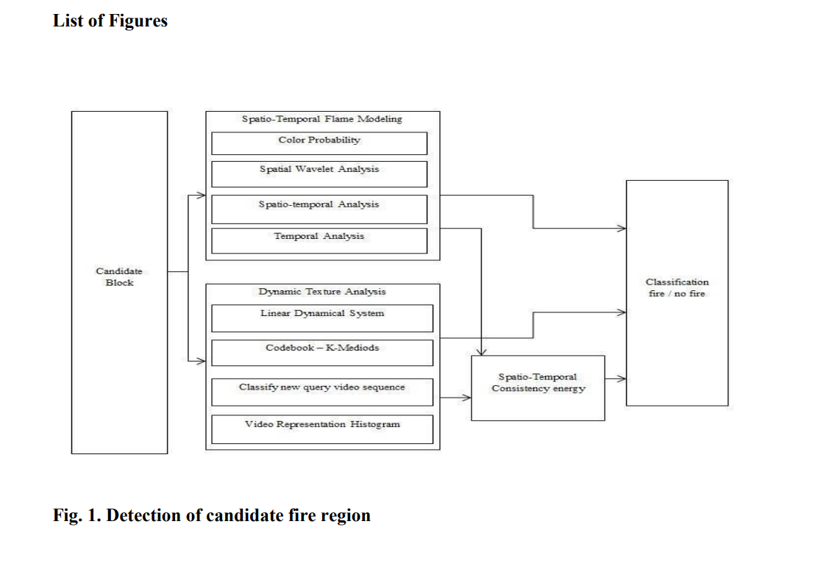

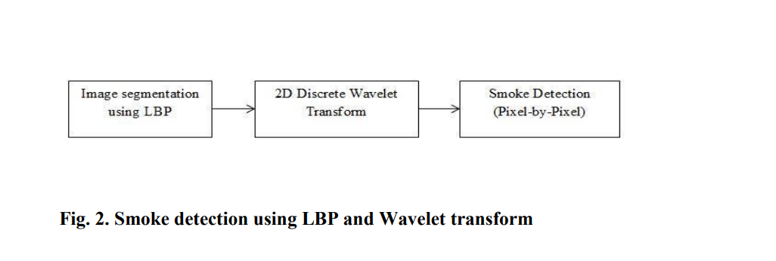

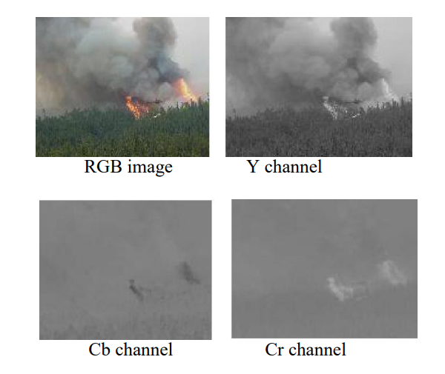

**Fig. 3. YCbCr color model**

